Enter the 2013 Bolton Conservation Commission’s
12th Annual FREE Photo Contest
We welcome images that celebrate our town’s unique environmental and historic beauty
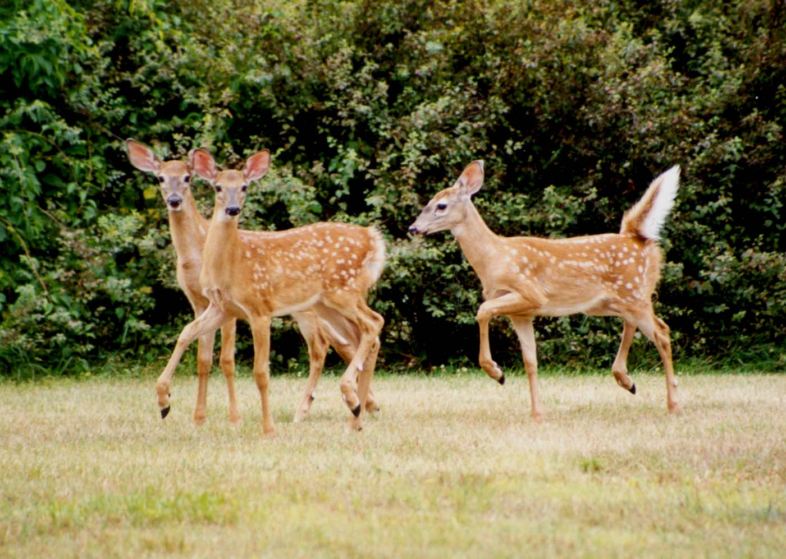1st Place, 2nd Annual Photo Contest “Fawns on Brookfield Rd” by Brenda Cataldo, Beauty of Open Space & Nature category
Catch a colorful sunset or glowing moonrise over your favorite landscape (any season). Share your most effective energy-saving idea, passive/active solar house or compost pile photo. Send us a pic of you and your family enjoying the great outdoors in Bolton. Capture a photo of a prancing Whitetail deer in your backyard or gather your family historical archives, scan a digital copy and send it on its way!
What to enter
Only digital photos with titles and names of photographer. No hard copy photos will be accepted.
Five Categories (any season/year):
1) The Beauty of Open Space and Nature in Bolton; 2) Examples of Green Building Concepts & Green Vehicles in Bolton; 3) People and the Environment in Bolton; 4) Wildlife in Bolton and 5) Historical Photos in Bolton.
Where to send
Submit all digital photos to BoltonPhoto@aol.com Be sure to include photographer's name, location, date of the picture, and category on e-mail or attachment title. Also include your address and phone number. Photos must be titled and with appropriate category: Example: Sunset over Bolton Lake, “Beauty of Open Space & Nature” by John Doe, etc...
Winning Photos
The three best photos in each category will be published on the Town of Bolton website, posted on the Conservation Commission bulletin board at Town Hall, and displayed at Bentley Memorial Library.
Prizes
All prizes will be awarded on Bolton Family Day, May 27th at the Conservation Commission booth. Such prizes include checks totaling $100, Books and Book Bags from the Bolton Historical Society, Personalized Boat Tour of Lower Bolton Lake for Two by Friends of Bolton Lakes, Custom Earth Day Recycle T-shirts and Guided Tour of Freja Park from the Bolton Conservation Commission, Professional Photo Shoot by Moments in Time Photography, Well water tests by Phoenix Environmental Laboratories, Wildlife artwork by Ray Hardy, Elderberry Plants by North Central Conservation District and Equipment rentals by Eastern Mountain Sports at Buckland.
Entry Deadline
All entries must be e-mailed no later than midnight of May 15, 2013
Judging
Photos must depict the town of Bolton, Connecticut and all decisions of the judges are final. Conservation Commission and selected judges look for sharp focus, good exposure, balanced composition, and appropriate subjects.

Contest Rules
1) Eligibility: Open to all residents of Bolton. Photographs must be submitted by the photographer, or include written permission. 2) All entries become the property of the Town of Bolton Conservation Commission, with shared rights for unlimited reproduction in print and electronic publications and promotional materials for an unlimited period of time. Published photos will be credited. 3) You may submit three entries in any category (total 15 photos). 4) Entries can be duplicate (scanned) digital pictures in color and/or black and white. 5) Each photograph submission must include photographer's name, location, date of the picture, and category on a separate attachment. Also include your address and phone number. Photos must also be titled with the appropriate category: “Beauty of Open Space & Nature”, “Historical Photo” etc. 6) Be prepared to provide the Bolton Conservation Commission with the written consent of anyone who appears in a photograph. 7) Photos must depict the town of Bolton, Connecticut and all decisions of the judges are final. Conservation Commission and selected judges look for sharp focus, good exposure, balanced composition, and appropriate subjects. 8) The Bolton Conservation Commission reserves the right to adjust any prizes and/or deadline(s) as the result of causes beyond its immediate control.

